
"Seraphicus Patriarchus" original under the care of the OFS.
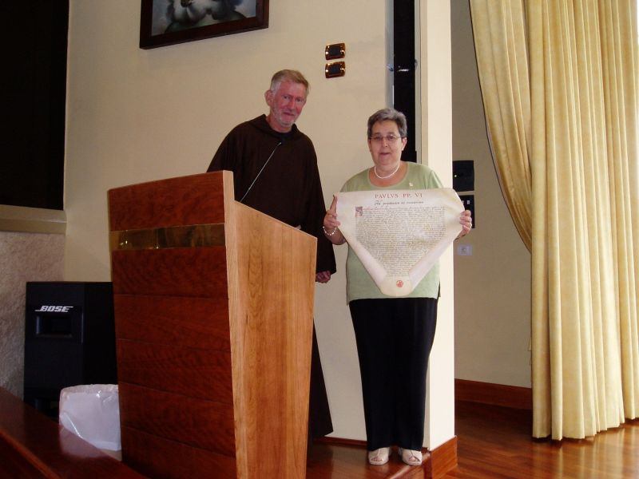

The Rule of the Secular Franciscan Order
is Approved and Confirmed
Pope Paul VI
In perpetual remembrance — The Seraphic Patriarch Saint Francis of Assisi, during his life and even after his beautiful death, not only attracted many to serve God in the religious family founded by him but also drew numerous members of the laity to enter his communities while remaining in the world as far as possible. Moreover, to use the words of our predecessor Pius IX: “it seems . . . that there was never anyone in whom there shone forth more vividly and who resembled more the image of Jesus Christ and the evangelical form of life than Francis. Accordingly he who was called the Herald of the Great King, was rightly hailed as Another Christ for he presented himself to his contemporaries and to future ages as Christ returned to life. Consequently, he still lives as such in the eyes of men and will continue to live for all ages to come.” (Encycl. Rite Expiatis, April 30, 1926: AAS, 18, 1936, p. 154). We are happy that the “Franciscan Charism” today is still a force for the good of the Church and the human community, despite the infiltration of doctrines and tendencies that alienate people from God and from the supernatural. With praiseworthy initiative and with common accord the four Franciscan families have striven for ten years to prepare a new Rule for the Franciscan Third Order Secular, or as it is now called, the Secular Franciscan Order. This was necessary because of the changed conditions of the times and because of the teaching and encouragement given them by the Second Vatican Council. Therefore, our dearly beloved Sons, the four Ministers General of the Franciscan Order, have requested that we approve the Rule presented to us. Following the example of some of our predecessors, the latest being Pope Leo XIII, we have willingly decided to grant their request. In this way, we nurture the hope that the form of life preached by that admirable man of Assisi will gain a new impetus and will flourish vigorously. Having consulted with the Sacred Congregation for Religious and Secular Institutes, which has diligently examined and carefully evaluated the text, we approve and confirm with our apostolic authority and sanction the Rule of the Secular Franciscan Order, provided that it agrees with the copy in the archives of the Sacred Congregation for Religious and Secular Institutes, beginning with the words “The Franciscan Family” and ending with “according to the norms of the Constitutions.” By this Letter and our apostolic authority, we abrogate the previous Rule of what was formerly called the Franciscan Third Order. Finally we decree that this letter remain in effect now and in the future, regardless of anything contrary.
Given at Rome at St. Peter’s, under the ring of the Fisherman, on June 24, 1978, the 16th year of our pontificate.
John Cardinal Villot
Secretary of State.

Dearest sister Encarnaciòn Del Pozo,
May the Lord give you Peace!
It is with great joy that we can finally say that the search has borne fruit, and we can return the original of the Apostolic Letter Seraphicus Patriarcha, which the venerated Pope Paul VI gave to the Secular Franciscan Order. We are well aware of what fundamental importance it is for the life of the Secular Order.
Therefore, it is with a profound feeling of communion that we place it in your hands after having taken care of it for all these years, also as a sign of our link in Francis, who never stops inviting us to be poor and simple in the world, each one in our own calling, but all called to recognize in Christ, the Love of the Father, the Saving Word, the Beauty of Life in the Spirit.
Dearest sister, as we feel ourselves more and more in communion in our lives, we thank each brother and sister in the Secular Franciscan Order for the prayer and support that each one has offered to us, the friars. Thank you and may the Lord gaze on you in blessing, show you his mercy and guide your footsteps in the Good.
With true fraternal affection,
Fra Mauro Jöhri

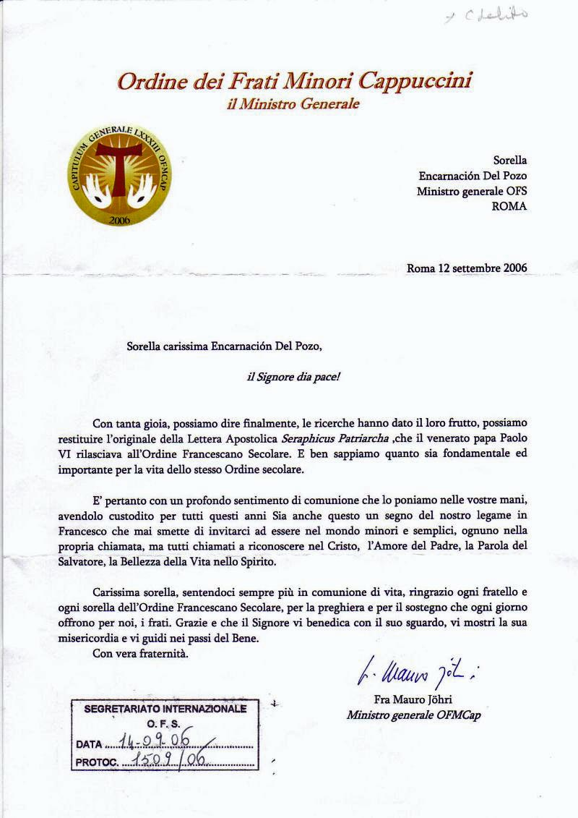
DECLARATION
Upon the request of the Minister General of the SFO, Encarnaciòn Del Pozo, and the decision of the Minister General Fr. John Corriveau and the Definitorium, the original of the Apostolic letter by Pope Paul VI “Seraphicus Patriarcha” approving the Rule of the Secular Franciscan Order, is hereby consigned to the Minister General of the SFO by Fr. Gandolf Wild, Archivist of the current Archives, for its preservation in the Archives of the Secular Franciscan Order.
Copy of the above Apostolic Letter is preserved in digital form in our General Archives as testimony of the document.
Rome, August 31, 2006
Fr. Luigi Marti
Administrator of General Archives
Fr. Gandolf Wild
Archivist of the current Archives

