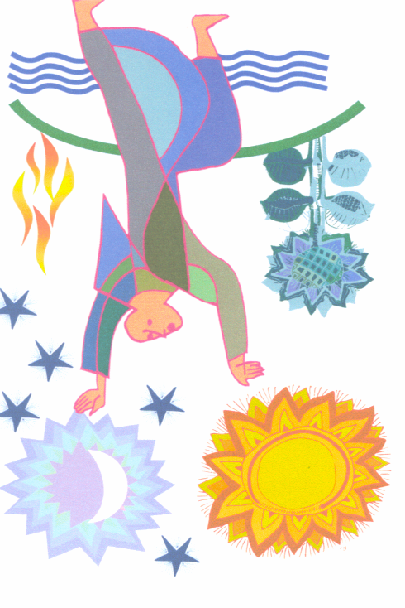

We should wish for nothing else
And have no other desire;
We should find no pleasure
Or delight in anything except
Our Creator, Redeemer, and Savior;
He alone is true God
Who is perfect good,
All good, every good,
The true and supreme good
And in Him
Is all pardon, all grace and all glory
For the penitent, the just
And the blessed who rejoice in heaven. Amen
St. Francis of Assisi

_____________________
will make their profession in the
Secular Franciscan Order
as members of
___________________ Fraternity

You are invited to attend
the Celebration of the Eucharist and
Rite of Profession Ceremony
______________________
_____________________
at

______________________
______________________
_______________________

Dinner reception following

To Be Professed:
Add names here

