SFO Professions at ___time________Mass _____date________________

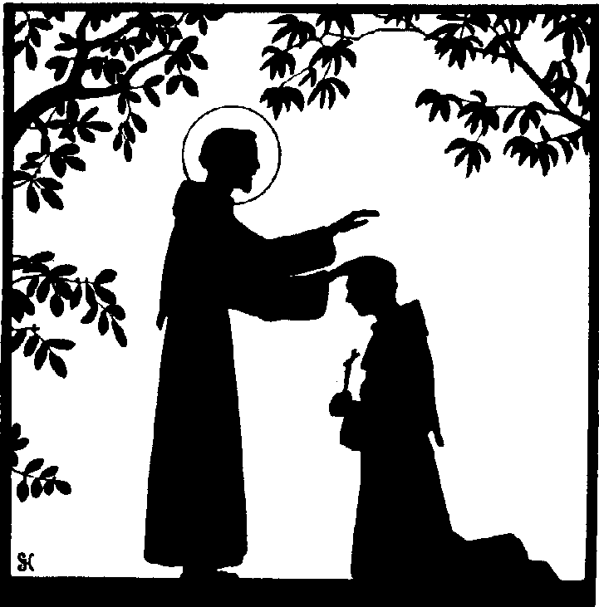
The _______________ Fraternity of the Secular Franciscan Order (SFO) happily shares the news of our upcoming professions. (Insert candidates names) will make a permanent commitment to the Gospel Life as they profess into the Secular Franciscan Order. This Rite of Profession will take place at _____________________ during the _______________ Mass on _____________________________.

Profession in the Order is the culmination of over three years of initial formation. At their profession the candidates promise to follow the Rule of Life of the Secular Franciscan Order, pledging themselves to live the Gospel in the manner of St. Francis by means of this Rule. St. Francis himself wrote the first “Rule of Life” for members of the SFO. Since Vatican II that Rule has been updated but remains true to the vision of St. Francis of Assisi. This Rule calls Secular Franciscans to live out their calling to the Franciscan life in a particular way in their homes and families, at work, in their parishes, and in the world.

If there is a reception that follows Profession, please add the details here. Reception follows _____________________________

The _________________________ Fraternity of the Secular Franciscan Order began meeting at ______________________ in ____ of 19____? For more information on the SFO please contact ____________.

