15 B 2024

Hot sun, soft breezes off the lake, rhythmic waves. My niece’s daughter on the ground, scoops up sand and packs it tightly into her bucket. She turns it upended and gently lifts it. To the delight of this young architect, her castle tower is formed. She’ll spend the rest of the afternoon dedicated to her work, carving out the moat, packing tightly the walls, building a bridge out of popsicle sticks.

In downtown Hollidaysburg, busy streets, passers-by to and from the Courthouse. A business man sits in front of his computer near the office window, shuffling papers, making assignments, crunching numbers, Bluetooth flickering on his ear. He, too, is in the midst of construction.

Two builders, two castles. They share much in common. Both have a mission; both are making something new. But there is a difference between the youngster and the business man. For all her seriousness, she approaches her work with detachment. At the end of the day, she will watch with joy as the waves wash away her castle. She will leave for home without sorrow, without fear, without regret. The business man may not be so wise. He may allow his commitment to his work to cloud his vision, thinking perhaps this might guarantee success, and that his work can last forever.

Today’s Scripture is about “ready, set, go.” For Franciscans it’s “listen, discern, go forth.” How blessed is God. And what a blessing God is! Long before He laid down the earth’s foundations, He had us in mind, had settled on us as the focus of His love, bringing us into His family, wanting us to enter as brothers and sisters into the celebration of His lavish gift-giving of His beloved Son.

Through the sacrifice of His Son, His blood poured out on the altar of the cross, we became a free people. Absolutely free. God thought of everything, provided for everything we could possibly need, letting us in on the plans He took so much delight in making. He set it all out before us in Christ Jesus. It’s in Christ that we find out who we are and what we are living for. God had His eye on us, had designs on us for glorious living, part of the overall purpose God is working out in everything and in everyone.

Signed and sealed in the Spirit, Jesus sends us forth to live this in a radical sign of the presence of God in the world. Redemption is at work through the hidden purposes of God, revealed to us so that we might become cooperating partners in the work of redemption.

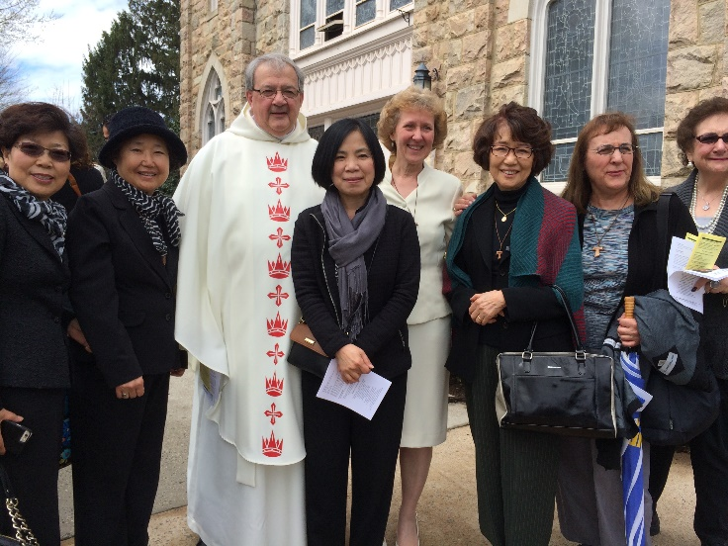 Let us look back over our Franciscan vocation and realize in a new way why God’s choices are so lovingly made, why the call is so timely, and why the conditions favoring authentic apostolate may well include simplicity and so few resources.