19 C 2025

As I sat on a rustic wooden bench this past week on a community retreat, I found myself surrounded by the voices of creation. Leaves rustling in the breeze. Birds singing sweetly in the trees. Magenta gladiolas standing tall and proud, zinnias bursting in radiant colors, squirrels lunching on acorns. I was lost in wonder and awe. Created things, written as in a precious book, God’s art bearing the imprint of the Most High. St Francis and I prayed, *“Praise and bless, my Lord, and give Him thanks, and serve Him with great humility.”*

In these five days our gaze was fixed on the present. Looking at the present with forward-looking eyes. Our community lives the realism of the present. The present is the only time within our reach, the past has already faded into history, and the future does not yet have a substance of its own.

In today’s Gospel, Jesus calls us to be vigilant, for us to understand God’s movement in our life. God continually passes through life. Jesus indicates the manner of this vigilance: *“Let your loins be girded and your lamp burning.”* This is the way, an attitude of a pilgrim, ready to set out on a journey. Not relying in comfortable and reassuring dwellings, but rather to be open with simplicity and trust to God’s passage in our lives, to the will of God who accompanies us towards the next destination.

The Lord always walks with us, guiding us that we do not err on this journey. We place our trust and faith in God and in each other on this journey toward ever new phases that the Lord points out to us day by day. God is the Lord of surprises, the Lord of true newness who is good, the supreme good.

The present is open to the future, step by step, and one day it will become the present. The overarching theme in today’s Scripture invites us--all of us--to be faithful and watchful, active, confident and hopeful. Human beings are hesitant when it comes to moving out of our comfort zone. Fear of the unknown paralyzes hope and confidence. A message of reassurance comes from the Gospel phrase, *“Do not be afraid, little flock,”* and serves as a reminder that faithfulness and watchfulness is rooted in a loving God who deliberately wants to gift us with good.

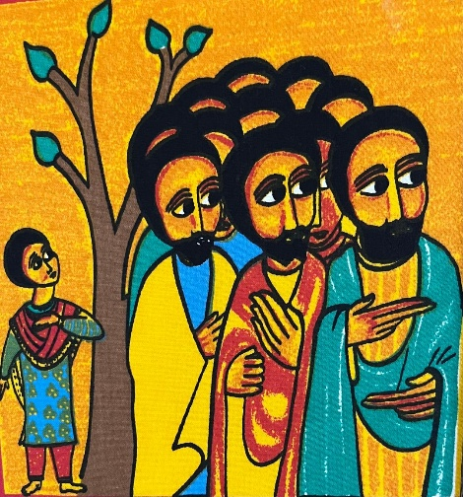The author of Hebrews reminds us that God Himself, who was faithful in our history, with be faithful in our history yet to be written. Faith is so dynamic, personal, and engaging. Faith with forward-looking eyes involves testing, holding on in the face of the unbelievable. It is seen in our actions. It makes us do what we would otherwise not do. Faith carries us to the brink. Then perhaps, emotional anxiety would shift to joyful anticipation and confidence.