2 Lent B 2024
At our Profession, as our name was being called out, we stood up, ready and willing with those Franciscan life-giving words, “This is what I want.” Did we know then what we know now? Of course not. Neither did Abraham in today’s first reading. His response, and ours as well, was made in faith. Opening up our self-sacrificing selves, come what may. Obstacles and Grace—accompaniments in our life’s journey.
At one time in Sacred History, there was a covenant between all of creation with earth and Noah. In today’s first reading we hear of a covenant between God and Abraham and the people. God wants everything from us. As God is the God of life and the future, God does not want our children or anyone else’s children in sacrifice. Abraham’s obedience was tested and proved. What God wants is our obedience.
But God, who made that terrible demand of Abraham and then rescinded it, finally made the same demand of Himself and did not rescind it. Like Isaac, Jesus had more than an inkling of what was to come. In the passage just before this Sunday’s Gospel, Jesus predicted His approaching passion and death: “He began to teach them that the Son of Man must suffer greatly and be rejected by the elders, the chief priests, and the scribes, and be killed, and rise after three days.”
Peter took Jesus aside to give Him some good political advice about how to succeed as a candidate for Messiah. Jesus would have none of it: “Get behind Me, Satan.” Understandably discouraged, the three most ambitious disciples needed some special attention from Jesus. So it was that He gave them their chance to “see that the kingdom of God has come in power.”
In their experience of Jesus transfigured, Peter, James and John saw not only Jesus clothed with the glory of God, but also Elijah and Moses, the fountainheads of prophecy and law. Both played roles in Jewish expectation of the end of time. Here Peter made the mistake of seeing Jesus as yet another figure announcing the end. But God, the one who asks for sacrifice, had different plans for Jesus: “This is my Son, my beloved. Listen to Him.”
Listen to what?—to the predictions about suffering and death that we do not want to hear, especially when they concern not only Jesus but also His disciples then and now. “Whoever wishes to come after Me must deny himself, take up his cross, and follow Me.” Today’s Gospel of the Transfiguration makes little sense without the passage just before it. The glory of the resurrection, for Jesus and for us, comes only after we have made our “Via Dolorosa” through the dark tunnel of death. God offers as the opportunity in Jesus to undergo death as a sacrifice rather than as a biological inevitability. That foretaste of the resurrection gave the downhearted disciples a sense that God could work good out of evil, joy out of sorrow. Should they have forgotten this lesson, God was willing to teach it to them again and again.
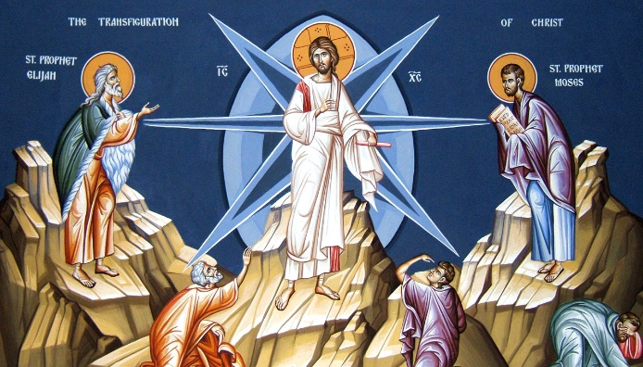
Anyone who has sat through a non-religious funeral or memorial service knows that in the long run it is easier to die as a Catholic. The serious-turned-trivial eulogies that concentrate on what so-and-so achieved in his/her professional career oppresses any listener who has a sense of the transcendent. The incensing and sprinkling of the body with holy water make more sense than do catalogues of educational laurels, business accomplishments, and intriguing hobbies. Did Father Christopher lay down his life, or did he simply lie down and die? Tell us the truth. The Transfiguration—a hint of better things to come—makes possible self-sacrifice for those who might otherwise only die.

