27 B 2024 – Feast of St Francis of Assisi

*“You are the holy Lord God who does wonderful things. You are the good, all good, the highest good, Lord God living and true. You are love, charity; You are wisdom; You are humility, You are patience, You are beauty, You are meekness, You are security, You are our hope, You are all our riches to sufficiency. You are our faith. You are all our sweetness, You are our eternal life: Almighty God, Merciful Savior”* (The Praises of God, redacted).

In commemorating the 800th Anniversary of the Centenaries of St Francis, all Franciscan hearts are filled with joy and inspiration to imitate the Saint’s life, as Christ Himself calls every Christian to live a holy life. Our faith is rooted deeply on love. God is love, the perfect love and the true lover. St Francis was aware that without a self-sacrificing love, he could do nothing unless he was immersed in love for the crucified Christ. It was this love that brought him in union with God. Love builds and strengthens relationships. Let us sing with Francis the “praises of God the Most High” that brings us into relationship with God, with one another, and with the wonders of creation.

The mystery, beauty, and sometimes the highly demanding nature of human relationships are front and center in today’s Scripture readings. In a world of indifference, self-centeredness, individualism, closure, fear of those who are different, the response is the call with the grace of holiness. Let us witness that Christ’s gift of love is still relevant. Let us desire to love Christ more, be motivated by love, and sealed by love. In Jesus’s mind, and that of the Church that receives His teaching, God desires that marriage be a communion of persons who are loving, learning, and growing together in relative peace and happiness.

In the English language one word can have many meanings. Take for example, the word “pot.” It can be something in which you boil your spuds; something in which you plant your geraniums. It could be the pile of money in the middle of the poker table your trying to win. It could even be the stuff that some people want to make legal to smoke, or the vessel filled with gold at the end of the rainbow. I think I have made my point.

It is no different with the word “marriage.” It’s the same word but it has different meanings in different times, cultures, and places. The understanding that Jesus has of marriage is very different from the Pharisees idea of marriage, and both differ from our culture’s understanding of marriage today. The definition of marriage our culture uses today is not the definition Jesus is presenting. Culture and Scripture may use the same word, but the meaning is quite different.

We cannot underestimate the importance in which Jesus held marriage. It was the setting for His first miracle. He uses marriage to describe the Kingdom of God in His parables. He refers Himself as the Bridegroom, and the Church as His Bride. He sees heaven as a wonderful wedding banquet on more than one occasion. In today’s Gospel, Jesus gives clear teaching on what He means by the word marriage, and everyone is upset with Him, even the disciples, and of course, the Pharisees who enjoy testing Him on matters of the law.

In defense, the Pharisees replied that Moses permitted a decree of dismissal be drawn up and so to divorce. Jesus corrects them that it was because they were so unteachable that Moses wrote this commandment. And Jesus quotes Genesis, “In the beginning of creation, God made them…”

We all know someone who is divorced and re-married. We all know someone who is in an irregular union or committed relationship. We all know people who feel called to live out their discipleship as a single person, who do not feel called to marry, or to enter religious life.

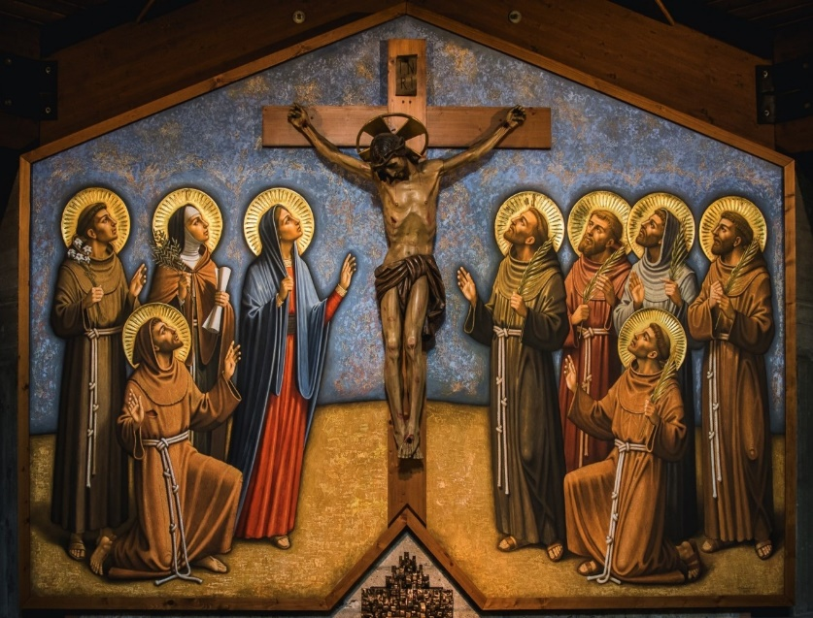 The Church has devoted so much of its laws to marriage. The Church teaches marriage is for life; that marriage gives life, fulfills life, builds up life and completes it. All of us need to hear what Jesus has to say, to accept His word and act upon it, to bring Him forth by a holy manner of life, even when we are challenged by His words.

Praise and bless my Lord and give Him thanks, and serve Him with great humility.