All Saints Day – Fr. Christopher


THE CLOUD OF WITNESSES

Therefore,
since we are surrounded by so great a cloud of witnesses,
let us also lay aside every weight and the sin that clings so closely,
and let us run with perseverance
the race that is before us,
looking to Jesus the pioneer and perfecter of our faith,
who for the sake of the joy that was set before Him
endured the Cross,
disregarding its shame,
and is seated at the right hand of the throne of God.

THE BEATITUDES---OBSERVE then RESPOND---by Micah Krey
The Eight Beatitudes are presented to us in today’s Gospel. Jesus is the authoritative teacher as He ascends the mountain. Before Jesus speaks, He observes. The curious, hopeful, desperate people are gathering, but not as skeptics nor opponents. The Beatitudes are not conditions Jesus demands. They are conditions He recognizes. Jesus does not tell them to become and live this way in order to receive blessing. He tells them that this is precisely where God’s blessing is already at work.
Blessed are those who mourn, for they will be comforted. When folks grieve the loss of life, when they mourn the cycle of violence, we have grown numb to this Beatitude says first “I see you.” It names our sorrow and assures us that our mourning does not go unnoticed. Jesus’ blessing here does not minimize pain. It brings pain into the very sphere of God’s presence.
Blessed are the meek, the merciful, the peacemakers. Where power is exercised with force, those with authority go unaccountable; where struggle for justice seems unattainable, their declaration reshapes what Kingdom life looks like. The meek are not naïve; they have experienced the world’s violence and kept their hearts open to compassion. The merciful are not weak; they refuse to let violence harden human encounters. Peacemakers do not seek passive calm, but work for reconciliation even when justice seems distant.
Blessed are you when people revile you for the sake of righteousness. At times truth is costly, when standing with the vulnerable attracts scorn, when tension surrounds compassion and accountability, Jesus here offers a blessing. He names the reality of faithful living in a fractured world. Resilience does not come from avoiding conflict. It comes from trusting that God is present with us in the midst of it.
Blessed are the poor in spirit, for theirs is the Kingdom of Heaven. This blessing names deep spiritual exhaustion so many of us carry now. It’s the sense that we do not have what it takes to fix what is broken, to make things right, or even to know where to begin. To be poor in spirit is not to lack faith, but to stand honestly before God with empty hands, aware of our limits and need. Here, Jesus says that the Kingdom belongs. Not as a future reward but as a present reality when certainty collapses, and control slips away. In a world that demands confidence and strength, this Beatitude calls our dependence and vulnerability a place where God’s love and reign are already unfolding.
The Beatitudes are not a strategy for fixing the world. They are not a moral checklist for surviving the world. They offer recognition of the Gospel. Jesus looks out to us, folks marked by loss, fear, displacement, and longing. Jesus is not telling us who we should become. He tells us that we are already in God’s sight. Blessed. Sent. Claimed.
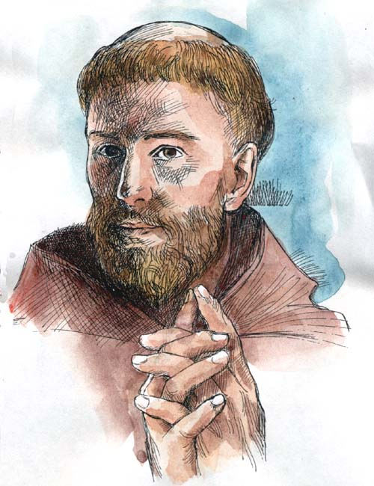
FRANCISCANS: A RECONCILING PRESENCE
There are times when we feel that problems are so overwhelming, so powerless to effect change, yet we engage in civic and religious communities cultivating a spirit of solidarity and decency, and peace in troubled times.
“The Catholic Common Ground Initiative” was brought to the attention of the Church by Cardinal Joseph Bernardin in 1996. What he said to the Church can be applied to society: as a call for a renewed spirit of civility, dialogue and generosity, to heal divisions; as a personal inventory, seeing what blocks concern for others: ambition and desire to make the winning point over opposition; as a willingness to evaluate ourselves rather than criticize others; as trying to see all sides of an issue rather than two sides--our own and the wrong one; listening to each other to understand and build agreement, not flaws and reasons to disagree.
BEATITUDES SEEK CONVERSION OF HEART
Let us be in touch with the mystery of God in our lives. Let us become aware of His active presence. Let us encounter God as loving and challenging us, inspiring and empowering us, a living engagement -- God With Us -- moving and walking forward together.
In Ron Rohlheiser’s OMI, The Holy Longing, he speaks of a tension in contemplating something and holding it inside the soul. When Mary stands beneath the Cross of Jesus and watches Him die, she carries a great tension that she is helpless to resolve, and must simply live with. Mary “kept these things in her heart and pondered them.” We are called upon to do the same kind of contemplating. If we are willing to contemplate and wait before we speak and act with a sharp or critical word, before we look upon our brothers and sisters unfairly and alienate them, and before we depart, we can bring reconciliation.
All tension arising from social, political, and economic concerns, from fraternity and personal worries, requires of us a reflective attitude that leads to a calming, reconciling presence when we incorporate into our thoughts and actions the hopes and longings of others. Let us renew the face of the earth one step at a time. Let us, like brother Francis and sister Clare, be reconciling messengers of peace and good to all we meet.
Consider the world so troubled by violence and so many other human situations. Where are the peacemakers who have the capacity to de-escalate rising nationalism? Consider governments on the verge of economic disaster. Who is listening to those without a voice, to the poor and homeless? Who looks out for the common good rather than for individual gain? Consider the Church whose moral authority fails to address compelling issues. How can the Gospel message of forgiveness be spoken with charity so as to restore confidence? Consider our families and communities affected by what is happening in the world. What is needed to restore balance and stability in widespread turbulence so that we might enliven and enkindle faith, hope, and charity?

GOD BLESS THE 250th ANNIVERSARY OF OUR NATION
National Anniversaries bring a variety of observances. Some emphasize celebration and gratitude. Others focus on failure and injustice. Still others seek to enlist Christianity in service of political agendas. The louder the public conversation becomes, the easier it is for us to mistake one of these voices for the voice of Jesus. Automobile and mattress sales make their own distinctive noise.
In today’s Gospel Jesus reminds us that as His disciples we are formed by Him. But we need not ignore our nation’s history. In good times and in bad we participate in the life of our country. Even the Secular Franciscan Rule directs our witness to civic life. We can give thanks for the freedoms and opportunities we have received, lament the times and places where our nation failed to live up to its ideals, pray for our leaders, and seek the welfare of our neighbors. Yet our ultimate allegiance belongs not to any political party or ideology but to Christ, our Crucified and Risen Lord.
We need not choose between gratitude for our country and our faithfulness to Christ. We should not confuse the two. Love of neighbor calls us into civic engagement. Love of Christ determines how we engage. Before we are Republican or Democrat, conservative or progressive, Americans or Immigrants, we are God’s people.

