4 Lent B 2024
We are presented today with another episode in the story of faith. Our ancestors in today’s first reading get impatient with desert living on dull food and the hope of water. And so, they rebel against God. Suddenly, they find themselves ankle-deep in seraph serpents, whose deadly sting drives them back to God. Moses heard God’s command: “Make a fiery serpent and mount it on a pole. If anyone is bitten and looks at it, he shall live.”
Before the time of Jesus, Wisdom tradition kept the story alive, reminded the people who gazed on the brass snake, that they were saved by the universal Savior. Of course, there is a special meaning here. Early Christians remembered that Jesus had turned the story into an allegory.
And so, Jesus’ disciples are those people. The serpents are the consequence of our sins, which will leave us dead. The One raised up is Jesus. Looking at the fiery serpent is believing in Jesus. The model of the serpent saved no one. But everyone who looks in faith at Jesus may have eternal life in Him.
The allegory contains another point. The people were disciplined for their infidelity—they were lead around a desert—dying to self-reliance and to pride. We are disciplined, too. Our desert is our own believing. When we commit ourselves to belief in God and in His Christ, we die to ourselves, to our self-reliance, and to our pride. Our profession as Franciscans reminds us daily of this.
Whether we gaze with longing into the garden, or with fear and trembling into the desert, of this we can be sure—God walked there first. When we who have sinned are challenged now to face the desert, we do not face it alone. Jesus has gone there before us, to struggle with every demon that has ever plagued the human heart. Face the desert we must. Jesus has gone there before us.
It’s time now of realizing the distance we have put between ourselves and God. It’s time now for recovering our desire for God—with ears ready to hear and really listen, with eyes ready to see to really perceive.
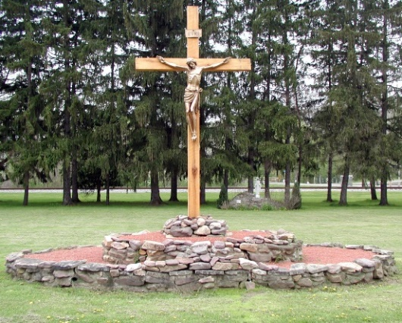
We turn to Christ crucified who was lifted up. We gaze upon the Christ of the Cross of San Damiano. We die to ourselves that God will give us true faith, certain hope, perfect charity, sense and knowledge. St Paul tells us today that we are God’s work of art, created in Christ, to live the good life.
Created in Christ, to live the good life, summed up in Christ, crucified and risen—is living contrary to the sense accepted in our culture. We, too, are lifted up, and crucified with Christ. We take up our cross, daily. Even if we are slow to listen and believe that our lives are rooted in the Word of God.
Our culture honors individual freedom, even when it is hateful and vicious. Our faith and our profession as Franciscans tell us we die to self in this. We die to ourselves in our culture when we experience that we are formed, well informed, well conformed to the One who lifts us up to Himself.
“Because of His great love for us God brought us to life with Christ when we were dead in sin.” St Francis speaks to this when he sings, in the Canticle, that physical death is not to be feared. Much more devastating is the death that is sin. The gift of faith is not a reward for anything we have accomplished. Faith reconstructs us from within. It gets down to those dark recesses in us and re-makes us there: “We are truly His handiwork…”

