5 Lent B 2024
Our readings today are filled with anticipation. “The days are coming,” Jeremiah prophesies in today’s first reading. “The hour has come,” Jesus says in the Gospel. The new covenant that God promised to Jeremiah is made in the “hour” of Jesus—in His death, resurrection, and ascension to the Father’s right hand—the glorification of the Crucified Majesty of God.
At the beginning of the Last Supper we hear, “His hour had come to depart from this world and go to the Father.” Likewise, in the prayer Jesus addresses to the Father begins, “Father, the hour has come; glorify Your Son so that the Son may glorify You.”
Today I would like to speak about an hour. Breathe! The “hour” of Jesus as a prominent theme in St John’s Gospel. “Hour” denotes the culminating moment of Jesus’ life and mission, the historic events of His self-offering. “So, they sought to arrest Him, but no one laid hands on Him, because His “hour had not yet come.” “He taught in the temple, but no one arrested Him, because His “hour” had not yet come.”
The references to Jesus’ arrest make it obvious when His “hour” would come at last. It would come in the final days of His earthly life, with His suffering, death, and resurrection. As I prayed and searched all the references to Jesus’ “hour,” I discovered a spiritual connection: all the hours point to a time that begun centuries ago in a city of Palestine, and they also point to a present time and place that is familiar to us today.
Jesus used the word “hour” to speak about the central mystery of faith—the work He had come to accomplish. His first recorded use of the word is on the day of His first miracle, the wedding feast at Cana in Galilee, Chapter 2. The wedding party runs out of wine. Jesus, to His mother: “What concern is that to you and to Me? My hour has not yet come.” To make sense of Jesus’ assertion “My hour has not yet come,” there is an underlying assumption, that Jesus anticipates an “hour” when something momentous will happen. Yet the time is not now. The assumption underlying the assertion, they have no wine? Jesus knew that when His hour did arrive, He would provide wine, indeed the finest of wine. But the definitive hour had not yet come.
Another instance of the “hour” is the conversation with a person who today might be called “marginalized: the Samaritan woman, who receives the first explicit teaching about Jesus’ “hour.” Chapter 4. “Woman, believe Me, the “hour” is coming when neither on this mountain (Garazin) nor in Jerusalem will you worship the Father. The “hour” is coming, and now is, when the true worshipers will worship the Father in spirit and in truth. Speaking of this “hour” goes beyond the historic events surrounding His Passion. At Cana, His words revealed that Jesus is expected to provide wine when the hour came. Now, with the Samaritan woman, Jesus reveals another dimension.
His “hour” is not only a time of providing wine. It’s more a time of worship—a radically new way of worship, which even the Jews in the Temple had never known. When the hour comes, the living water of the Holy Spirit will be poured out to enable all people to worship “in spirit.” Now, it’s not where you worship that’s important, but how you worship. Nor is worship restricted to the Chosen People or the Jerusalem Temple. Worship “in spirit” is available even to those whom the Jews had considered spiritually dead. How can this be? The answer, again, is in the hour.
In Chapter 5, Jesus explains to the people why He was healing on the Sabbath: “Truly, truly, I say to you, the “hour” is coming, and now is, when the dead will hear the voice of the Son of God, and those who hear will live:” the third dimension of the hour. Not only is it a time of worship when the “best wine” will be provided, but also a time when the Word of God will bring people to repentance and forgiveness—in short, to new life.
Jesus next discussion is today’s Gospel, Chapter 12. In Jerusalem, some Greeks approach Philip and request an audience with Jesus. Philip and Andrew inform Jesus, and Jesus responds in a way that is unexpected: “The hour has come for the Son of Man to be glorified. Truly, truly, I say to you, unless a grain of wheat falls into the earth and dies, it remains alone; but if it dies, it bears much fruit.”
Speaking of death and fruit and grains of wheat—there’s lots going on here in this rich passage. This exchange takes place at Passover. The central rite of the Passover feast is the sacrifice of a spotless lamb. Jesus is explicitly called the “Lamb of God.” The “hour” of the Lamb, is Passover. This Passover is more significant because, now, not just the children of Israel but the nations—the Gentiles, the Greeks—have come to find liberation.
But Jesus does not use the “lamb” metaphor. Jesus speaks of wheat instead, and He speaks of wheat “dying” to produce “much fruit.” And how would that fruit manifest itself, once the grains were harvested? As bread, of course.
Now is “the hour,” Jesus says. It is Passover. Jesus is the Lamb. He is speaking of His own sacrifice. It becomes more explicit in later verses, when, speaking again of His hour, Jesus says, “Now is My soul troubled. And what shall I say?” Father, save Me from this “hour?” No, for this purpose I have come to this “hour.” Father, glorify Your name.”
Let us not miss the importance of this moment in this divine drama. Jesus is offering Himself here as the perfect sacrifice—He was offering Himself. He was not the hapless victim of a Roman execution; He was a victim of love. His life was not taken; it was given. Before Pilate, Caiaphas, or Herod could decree His death, Jesus gave up His life. Before anyone else could lay a hand on Him, He celebrated the Passover, and He transformed the Passover into the Lord’s Supper—the fruit of the grain of wheat, after it has fallen into the ground and died.
We know from the Synoptic Gospels, Jesus blessed the bread and the chalice of wine, pronouncing them to be His body and blood. But John does not recount the details of the Supper. Rather, towards the end of the meal, John relates, Jesus “lifted up His eyes to heaven and said: Father, the “hour” has come; glorify Your Son that Your Son may glorify You, since You have given Him power over all flesh, to give eternal life to all whom You have given Him.”
We know when this will happen: the hour. We know what will happen: human beings will participate in the glory and communion shared by the Father and the Son—“in the Spirit.” The High Priestly Prayer of Jesus, Chapter 17, the Lord prays, “that they may all be one; even as You, Father, are in Me, and I in You, that they also may be one in us.”
Let us not miss the significance of what Jesus’ hour will bring. Jesus is not saying that our oneness will be like the oneness of the Trinity. Jesus is saying that our oneness will be the oneness of the Trinity. Not something similar. But identical. In that hour, we will know the most intimate communion with God. “Holy communion” is what St Francis lived for, what he died for, and what he was marked for on his body at La Verna. Beyond the physical pain, Francis wanted to feel what was going on in the mind, heart, and soul of Jesus.

The glory of God shines on the world from the cross, as love is revealed. The glorification of Jesus takes place through the cross. Jesus goes through the whole Paschal Event—death, resurrection, ascension to the Father—before He achieves the glory that was His before the world was made. Jesus’ glorification is intimately associated with the cross, but then reaches beyond the cross into His return to the Father, producing the “fruit bearing” of the disciples, who live under the direction of the Spirit.
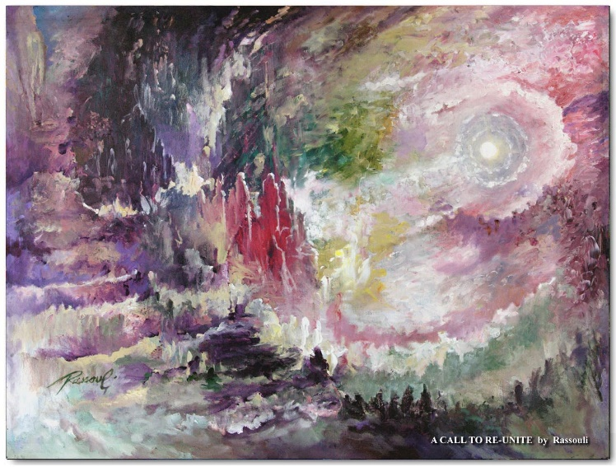

Rassouli, “Call to Re-Unite”

