6 B 2024
If there is one spiritual principle that most people are committed to, it is this: “Cleanliness is next to godliness.” It is not enough for us just to be clean—we have to be “squeaky” clean. Judging by the quantity of TV commercials for soaps, shampoos, deodorants, bleaches and detergents, cleanliness has become a substitute for godliness.
In the midst of our routine of cleaning, bathing, washing, showering, soaking, scrubbing, mopping, and rinsing, we are challenged today to deal with the starkly opposite condition—uncleanliness. The Old Testament’s strict law against leprosy created a social distance that effectively separated the diseased person family, friends and community. Leprosy was the AIDS of the Old Testament.
Jesus knows this law as well as any other rabbi of His day. But He chooses to break the law in a most deliberate and decisive way—He actually stretches out His hand and touches the leper who came for a cure. Touches him. Inexcusable! Irresponsible! But it works! Jesus’ tender touch makes the leper clean—without the benefit of Dial, Tide, or Suave.
Jesus always addresses the situation before Him. Jesus, “the perfect friar.” Thank you Franciscan St Marianne Cope and Sacred Hearts Father St Damien of Molikai for stretching your hearts and hands, to witness that leprosy is not the most painful, fatal, contagious, or incurable of diseases. It certainly has not been since Dr Hansen isolated the rod-shaped bacillus that causes true leprosy.
The memory of a distant metaphor from the past still lingers, the “moral leprosy of sin.” “Sin is moral Hansen’s disease.” Including other skin disorders named leprosy by the Bible, dare the one to try, “Sin is the heartbreak of psoriasis,” though the point would get washed out into a suds of giggles. And who would risk, “the disciple who gives oneself to sin is like the girl from Ipanema with eczema.”
All kidding aside, let’s address the situations before us as professed Franciscans: if you see Christ, be Christ. Imitate Jesus’ example: avoid offending people, act not for self but for the other, feel the pain as if it were your own, console the hurting, bring joy to the saddened, create hope for the disconsolate, give what is needed, work without counting the cost, do everything for God’s glory, not your own. “Listen--engage. Discern—embrace. Go forth—empathize.”
In just a few days Jesus is going to reach out and touch each one of us. The middle of the week is Ash Wednesday. Jesus will stretch out His hand and touch our foreheads with ashes. We who think we are so very clean are declared to be—dust. “Dust you are and to dust you shall return.”
We are not just dusty or dirty. We are dust. We are dirt. We are sinful mortals. Our condition is terminal. It will take more than a case of Dial or a carload of Tide to make this mess clean. Only Jesus has the cleansing power of His boundless mercy to make and keep us clean.
Our pre-Lenten prayer is simply “Jesus, cure us!” Jesus says, “Be cured!” When this Forty-day wash-and-rinse cycle of Lent is finished, may we sparkle, shine, and shimmer in the Light of Easter.

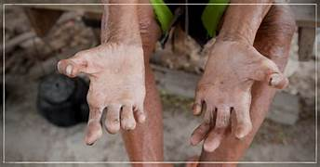
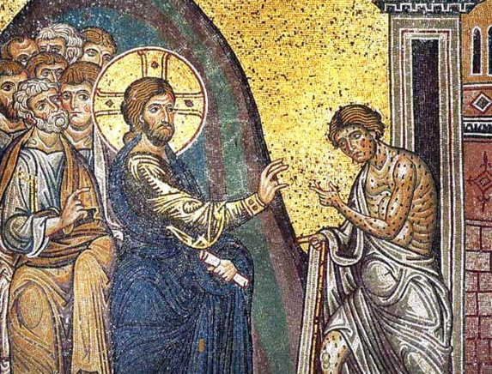

FYI: embraceavillage.org “What It is. What It’s Not.”

