Christ the King B 2024

There is an old Chinese story about an emperor looking for his successor. He devised a test. He invited all the children of the kingdom to the palace, and to each of them he gave a clay pot filled with dirt. He also gave each of them a single seed. He said to the children, “This seed will determine your future. You are to take it home and plant it, water it, and care for it. In one year, bring back your clay pot and show me the fruits of your labor.”

Now, among the children who returned that day was a young boy. His name is Ling. He took his pot home and planted the seed. He carefully watered and placed it where it could receive sunlight. But nothing happened. Even after months of care, his clay pot remained barren.

So when the time came to return to the palace, Ling did not want to go. But his mother said, “Ling, you have nothing to be ashamed of. You did exactly what you were told. Go and show the emperor your clay pot. So Ling went.

When Ling arrived at the palace he was amazed at the beautiful flowers and plants that filled the clay pots of all the other children. When the emperor surveyed the entire scene, his eye landed on Ling’s barren pot. “What is your name, young man?” the emperor said. Then the emperor bowed to Ling. He addressed the other children, “A year ago I gave each of you a clay pot and a seed. The seed had been boiled, so there was no way it would ever grow. Yet, when I came here today, I see pots filled with all the plants of my kingdom. Master Ling alone among all of you was the only one who had the integrity and the honesty to bring back the barren pot, even though by doing so, he risked ridicule and rejection. Living with honesty and truth is difficult. It is also a sign of greatness. Therefore, let us all bow to Master Ling, the next emperor of our kingdom.”

Today we celebrate the Feast of Christ the King. The feast is good for us. It tells us about the authority of Christ is supreme, that the power of Christ is real and active in our midst. Living the truth requires courage, courage to face what is real in our lives, courage to respond to that reality. Living the truth is refusing to lie to others, to ourselves. Those who live the truth refuse to live a lie. Lying can hurt us, lying can destroy us.

If our faith means anything, it means that whatever forces control us, whatever problems attack us, whatever truth we have to face, Christ’s power is greater. When we turn to Christ as our King, we find courage to face the truth, and then take the next best step on to a full life.

In today’s Gospel, the centerpiece of the Passion Story according to St John, is the long confrontation between Jesus and the Roman governor, Pontius Pilate. Jesus tells Pilate, *“All those who belong to the truth, hear My voice.”* The adversaries of Jesus are trying to make out that Jesus is King—King of the Jews—in the sense of a messianic pretender to the throne of David, a threat to Roman rule. Jesus owns His kingship and redefines it. The Kingship of Jesus is not the kind of worldly rule that could rival that of Rome.

All kingship requires allegiance. The allegiance that Jesus has is an allegiance from those who are *“on the side of truth,”* of love, in that “lifted up on the cross, Jesus will draw all people to Himself.”

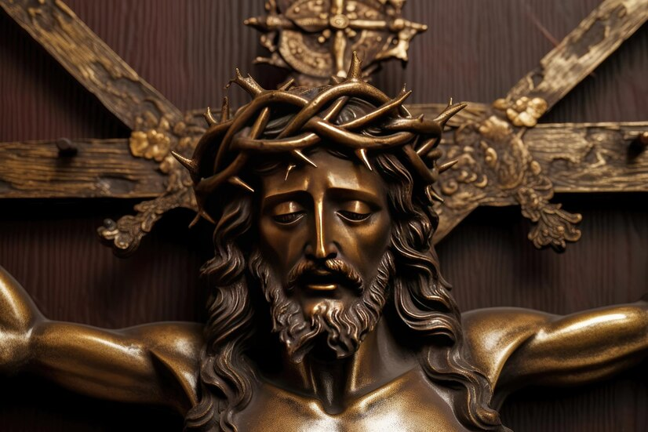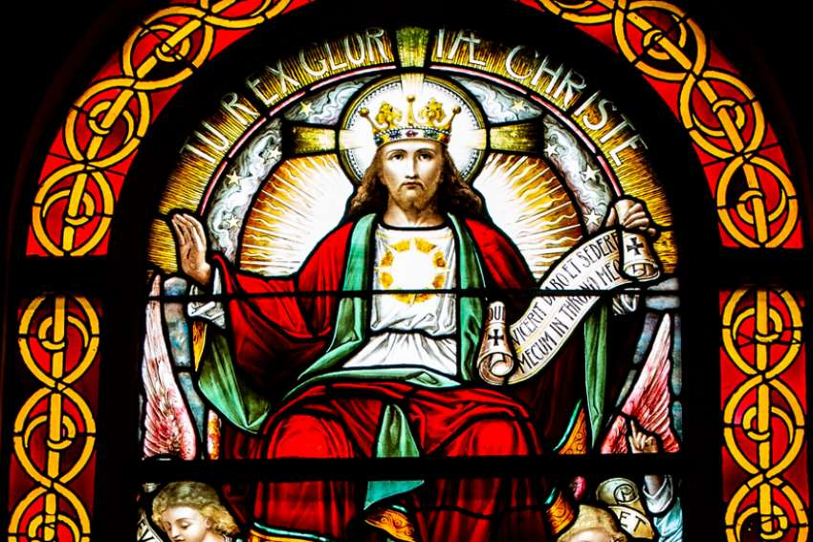We are called to belong to the truth, to claim what is real in our lives, living a Catholic Christian Franciscan life, and to follow the teachings of Christ and His Church. Should your clay pot is barren, admit it. Should there be problems in your fraternity, in your family, or at work, own them. Should there be addictions that control you, admit you are helpless before them. Stepping into the truth will lead to stepping into life. Claim what is real. Live what is true. Christ is our King. Christ is our Truth. Christ is our Hope of glory.