Congress of National Spiritual Assistants in Progress in Rome
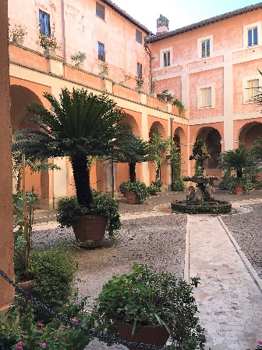
CNSA USA members Fr. Christopher Panagoplos, T.O.R, and Fr. Jerome Wolbert, OFM, are in Rome this week (November 10 – 15, 2019), attending the Congress of National Spiritual Assistants to the OFS. Fr. Christopher arrived on Friday, November 8th, and enjoyed some fraternity time at the Motherhouse of the Third Order Regular, The Basilica of Saints Cosmos and Damian, (courtyard shown at left), situated in the Roman Forum. Fr. Joined T.O.R. Friars from the Philippines, Paraguay, Croatia and Brazil.
The congress, a gathering of National Spiritual Assistants to the OFS and YouFra from around the world, is being held at the Pontifical University of St. Bonaventure, commonly called the Seraphicum. The Seraphicum is the international study center of the Friars Minor Conventual in Rome.
Some of the topics and presenters at the Congress are:
- OFS History and Identity – Fr. Pedro Zitha, OFM, (General Spiritual Assistant)
- OFS Official Documents – Tibor Kauser, OFS, (OFS General Minister)
- OFS Spirituality – Fr. Amando Trujillio-Cano, T.O.R., (General Minister and General Spiritual Assistant) (The full text of his presentation is available here Franciscan Spirituality .
- Spiritual and Pastoral Assistant to the OFS-YouFra, and Formation Process in the OFS-YouFra – Fr. Francis Bongajum Dor, OFM Cap. – (General Spiritual Assistant)
- Relevance of the Franciscan Charism for Today – Fr. Alfred Parambakathu, OFM Conv. – (General Spiritual Assistant)
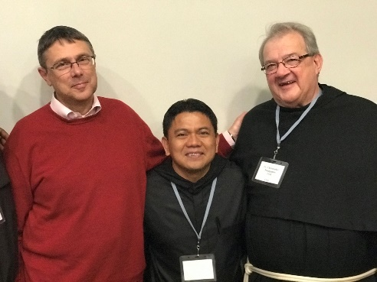
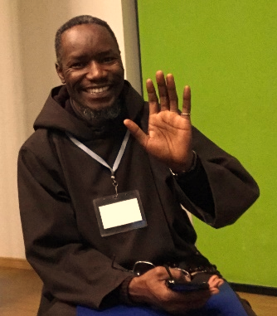
Among those in attendance were some familiar faces. Tibor Kauser, our General Minister, pictured here with Fr. Alejandro Isare, T.O.R., from the Philippines, and our own Fr. Christopher, and Fr. Francis Dor, who was with us at Chapter in 2016 and 2018.
We look forward to our CNSA Friars sharing insights and inspirations from the Congress when they return, and wish them safe travels.

Greetings from our General Minister, Tibor Kauser, OFS

