20 C 2025

Today, Jesus warns the disciples that the time for decision has arrived. Jesus’ coming into the world coincides with the time for decisive choices. The option for the Gospel cannot be delayed. To make this call clearer, Jesus alludes to the fire that He Himself came to bring: *“I came to cast fire upon the earth, and would that it were already kindled.”*

These are not measured words. This is an impassioned outburst, the eruption of the heart of Jesus that drives Him. He has come to fulfill a mission, and He is impatient for it to be accomplished. The fire He wants to cast on the earth is also inside Him, a propelling force, causing inner anguish.

This fire is not of His making. Jesus is not a reluctant prophet trying to control it. It has been placed there by the Father, for divine purposes. These words are meant to shock the disciples to abandon their attitude of laziness, apathy and indifference, so as to welcome the fire of God’s love. Jesus is the obedient One looking ahead to the blaze of accomplishment. It’s the love which St Paul speaks of, that this love *“has been poured into our hearts through the Holy Spirit.”* The casting of fire releases the Spirit, purifying, empowering, animating and enlightening life to love God and love our neighbor. The Spirit whom we all have, who dwells within us.

The anguish Jesus takes on is His impatience for His mission to be accomplished. His death and resurrection will bequeath the same Spirit to His disciples, and send them on a mission of forgiveness and reconciliation. When the disciples understand the revelation of Jesus’ dying and rising, His fire will pass into them, with their *“hearts burning”* within them. The divine plan of God emerges, *“Thus it is written, that the Messiah is to suffer and to rise from the dead on the third day, and that repentance and forgiveness of sin is to be proclaimed in His name to all the nations.”* The fire that began with Jesus casting it upon Israel, will now blaze throughout all nations.

Jesus is the Messiah, sent by the Father, to establish His rule pf justice, love and peace. This will mean good news for the poor, healing for the sick, and liberation for the enslaved and oppressed. Jesus’ mission was to set the world on fire, not with the fire of hatred and division, but with the fire of an unquenchable and unconquerable love, especially His outreach to the poor and marginalized, with the fire that represented an absolute reversal of the unjust status quo, the powerful religious and political elites of His day. it was this awareness when Jesus said, *“I have come not to bring peace on earth…but rather division.”*  Shocking and contradicting in everything we know about Jesus.

Jesus’ way of establishing God’s reign on earth was not the way of violence. He rejected the politics of violent revolution of the Zealots, rejected the strident nationalism of the Pharisees which fostered all kinds of divisions among the people. Instead, Jesus chose the path of redemptive suffering. His model: *“the suffering servant”* of the Lord.; to turn the other cheek; to walk the second mile; to take up the cross. He defeated evil by suffering it in love and forgiving His enemies. Jesus desired peace, but not peace at any price, not the false peace achieved by violence or by compromise, but by being faithful to His mission. St Francis would imitate Jesus’ mind and heart in his engagement with the Sultan.

Following Jesus, Francis admonished that those who wanted to follow him had to be ready, to leave home and family, and enter into a new family of sisters and brothers. To follow the way of truth and love, of freedom and justice is also going to arouse the hostility of those who feel threatened by goodness. To be true to one’s convictions and one’s integrity. The one who leaves family for the sake of Christ and the Gospel, shows a greater love that will never cease.

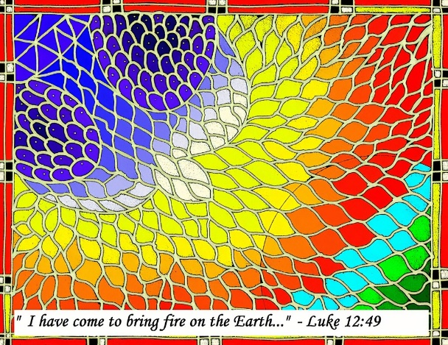Here is Jesus who brings division and anger, and even a sword for His own mother, as Simeon warns. But this is still Jesus who has come to announce the reign of God on earth. Part of that announcement is surely division and hard choices, both are parts of the love Jesus brings.