YouFra Booth
For ordering information contact Kathleen Molaro at kmmolaro@gmail.com
Profits from all sales will be invested in our young people’s attendance at the
YouFra International Gathering/World Youth Day, August 2023.

YouFra Essentials “Getting Started” Kit
Everything you need to get started! Flash drive containing what the FY/YA Commission considers YouFra Essential Documents, and materials developed for YouFra Faith Development Sessions. ($10. Each)

Picture books for our youngest Franciscans
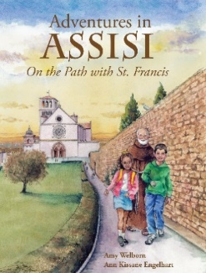
Adventures in Assisi: On the Path with St. Francis
By Ann Welborn & Ann Kissane Engelhart
Children will learn about Francis and Assisi through story and illustration.
Recommended for elementary grades.
Retail price - $15.99
Q price - $10.00
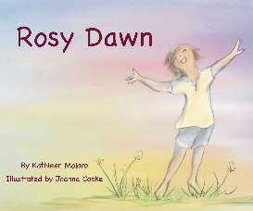
Rosy Dawn
By Kathleen Molaro; Illustrated by Joanna Cooke
In her picture book, Rosy Dawn Kathleen Molaro, OFS, invites readers to accompany a child from dawn until tucked in bed for the night. Each part of the day reflects a different activity along with a subtle change in outdoor color. Kathleen’s poetry and Joanna Cooke’s artistic details will entice young readers outside for a closer look at God’s beautiful creations. ($16.50)

