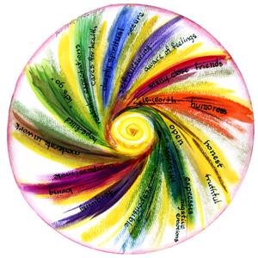
Regional Spiritual Assistant Workshop
August 29 – 30, 2018
The Canonical and Pastoral dimensions of being a Spiritual Assistant to the Secular Franciscan Order
presented by the:
Conference of National Spiritual Assistants (CNSA)
Savior Pastoral Center,
Kansas City, Kansas

Wednesday, August 29th
5:00 pm Mass (Chapel)
6:00 pm Dinner and Introductions (Dining Hall)
7:30 pm Evening Prayer (Chapel)
8:00 PM Social (Keleher Conference Ctr foyer)
Thursday, August 30th
7:30 am Morning Prayer (Chapel)
8:00 am Breakfast (Dining Hall)
9:00 am Build with Living Stones –
(Keleher Conference Ctr)
Fr. Christopher Panagoplos, TOR
10:15 am Break
10:30 am Presence in the Role of Spiritual Assistant – The Call within the Call – Our Effort. God’s Grace – (Keleher Conference Ctr)
Fr. Christopher Panagoplos, TOR and Mary Frances Charsky, OFS
11:30 am Discussion/Q&A

12:00 Noon Lunch (Dining Hall)
1:30 pm Rules and Guidelines for selecting and appointing a Spiritual Assistant. – (Keleher Conference Ctr)
Br. Alexander Escalera, OFM Cap., and
Fr. Jerome Wolbert, OFM
2:45 pm Break
3:00 pm Open Forum (Keleher Conference Ctr)
4:30 pm Evening Prayer (Chapel)
5:00 pm Mass (Chapel)
6:00 pm Dinner (Dining Hall)
The Formation Visioning Workshop begins after dinner on Thursday. Regional Spiritual Assistants are welcome and encouraged to attend.

