Trinity Sunday C 2025

Last Sunday on Pentecost, Pope Leo XIV said, *“The day has dawned upon us when, glorified by the Lord’s Ascension into heaven following His resurrection, the Lord Jesus sent the Holy Spirit. Today, also, what took place in the Upper Room takes place anew in our midst. The Holy Spirit descends upon us.”*

The Holy Spirit, gift of the Father and the Son, comes, giving us the grace to receive a new way of seeing things, and understanding that helps us to interpret current events, and to experience the presence of the Risen Jesus. This gift is the love between Jesus and the Father who comes to dwell within us, the love of the Trinity that overcomes our fears, shatters inner chains, heals wounds, anoints with strength and grants courage to go out and to proclaim the mighty works of God.

Where there is love, there is no room for prejudice, for “security” zones separating neighbor from neighbor, for the exclusionary mindset that, tragically, we now see emerging in political nationalisms. Where there is love, unity and fraternity live.

The Holy Trinity is dynamic and interrelated *(FUN Manual, Basic Catholic Doctrine, pg 9).* God the Father, Source of everything that exists, is ultimately beyond all expression. Yet, in infinite silence, expresses Himself in and through the Word, which is the expression of the Inexpressible, even to the extent that the Word is that same divine nature. St Augustine theologized that the Holy Spirit is the relationship, the flow of love, from the Father to Son, and from Son to Father— thus, there is both *distinction* (the Father is not the Son or Spirit) *and unity* (there is only One divinity).

Every approach to the Father is through Jesus. Jesus is the Way. He said this to us. No one knows the Father except the Son, and anyone to whom He wishes to reveal Him. St Francis desired to imitate Jesus—Christo-centric as the only way to be in relationship with the Father, conforming himself in the image of Jesus so much so that Francis also is a beloved son.

Francis experiences the Father’s love with trust, familiarity, astonishment, and thankfulness, fully aware of his “littleness.” It is in this awareness that God loves him, and makes Francis burn with an ever-greater love, with a more determined desire to be united to Him, offering himself completely—*like the Son*—in conformity and unity.

Pope Leo recalled that Benedict XVI said the Holy Spirit bestows understanding, overcomes the breach—the confusion of mind and heart that sets us one against the other. The Spirit opens borders. So, too, the Church, to open hearts and lives to love—to break down the barriers between class and race, to live in relationship, as Francis understood, in God who is “Perfect Trinity and Simple Unity.” This is the reality Francis charges all the brothers to recognize and hold dear in all they do.

Francis experienced the grace of being a beloved son, and desired to be a perfect disciple of Christ, in whom we do not recognize “paternal” attitudes, but rather “filial” and “brotherly” ones. *Fraternitas!* In the presence of his father Pietro, Bishop Guido, and his fellow citizens, Francis declared he had only one “Father, who is in heaven.”

From the Earlier Rule, *“Fear and honor, praise and consecrate, thank and adore the omnipotent Lord God in the Trinity and in the Unity, Father and Son and Holy Spirit, creator of all things.”*

In the first Admonition Francis brings us back to the relationship between the Father and the Son, that the *“Father who lives in an inaccessible light”* and can only be seen in the Spirit.

Also in the concluding prayer of the Letter to the Whole Order, Francis prays, *“Almighty, eternal, just and merciful God, grant us in our misery that we may do for Your sake alone what we know You want us to do, and always want what pleases You so that, cleansed and enlightened interiorly and fired with the ardor of the Holy Spirit, we may be able to follow in the footsteps of Your Son, our Lord Jesus Christ, and so make our way to You, Most High, by Your grace alone, You who live and reign in perfect Trinity and simple Unity, and are glorified, God all-powerful, forever and ever.”*

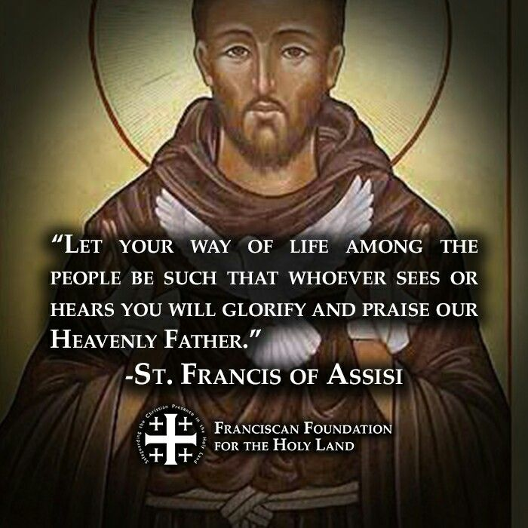*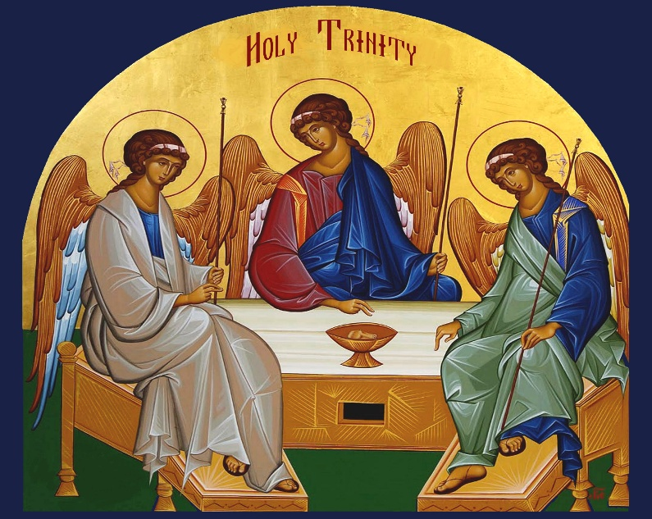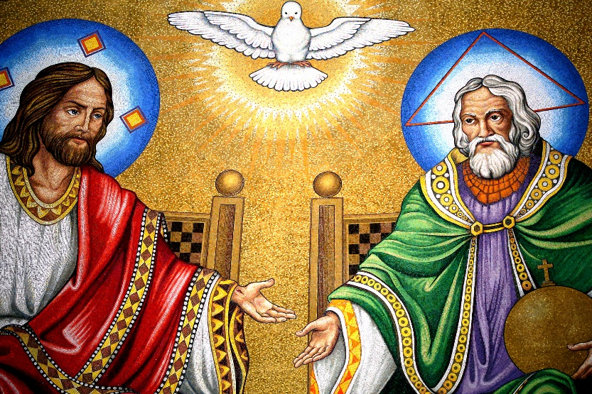*“As Franciscans, let us reconnect, establishing a truly vital relationship—a life-giving union—with the Lord, “to convert ourselves” into authentic “trinitarian” sisters and brothers, like Francis, to reach out to the Father, through and with the Son, by means of the grace of the Holy Spirit” *(Spirituality of the Secular Franciscan, Cristoforo Piacitelli, OFM).*